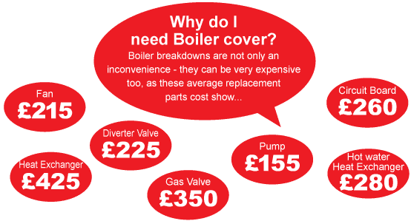

Home phone no____________________ Mobile phone no__________________

Email address_______________________________________________________

Boiler make_______________________ Boiler model______________________

Fuel type Gas LPG Oil

Level of cover required Bronze Silver Gold Platinum

Cover start date____________________

**APPLICATION FORM**

Name

Address 1

Address 2

Address 3

Address 4

Address 5

Postcode

Dear Name

Don’t get caught out if your boiler breaks down – protect yourself with a Boiler Cover Plan from Gasway – your local heating experts that you can trust.

If the worst does happen and you’re left without heating or hot water, not only can it be very difficult to get hold of a reliable heating engineer quickly, but if parts are required to solve the issue it could be very costly too. (Just look at the illustration above).

Here are a few key reasons thousands of people choose to use us:

* We’re the only company that guarantee to be with you the same day you report a fault*.
* We never charge an excess
* All parts and labour covered**
* Annual service included**.
* Unlimited call outs

We have different levels of cover to suit every budget and these have been outlined overleaf.

To start enjoying the added security of a Gasway Boiler Cover Plan simply call us free on 0800 074 3030 and speak to one of our friendly team. Go online: [www.gasway.co.uk](http://www.gasway.co.uk) Or complete the application below and return to the freepost address stated overleaf.

Yours sincerely

* providing call received by 12 noon.

Agent name ** subject to level of cover chosen.

Name

Address 1

Address 2

Address 3

Address 4

Address 5

Postcode



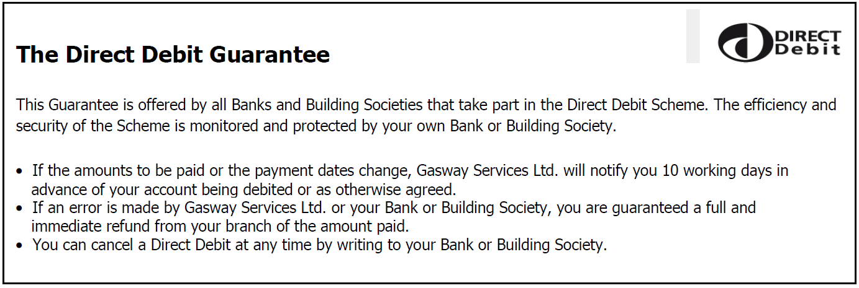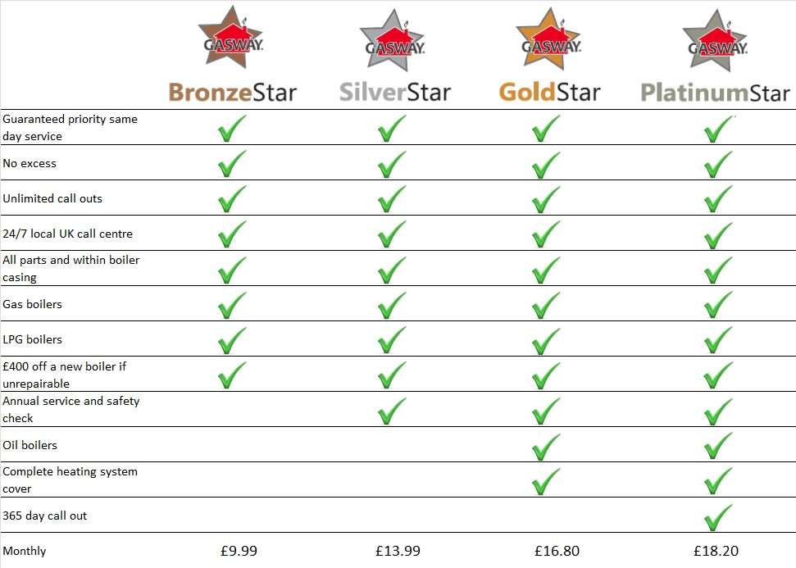

Freepost RSER-LKUH-BJRG

Gasway Services Ltd

18 Burnet Road

Sweet Briar Industrial Estate

Norwich

NR3 2BS

Name(s) of account holder(s)_____________________________________________

Account number 

Sort code 

Name of bank/building society_____________________________________________

Signed______________________________ Date______________________________

**DIRECT DEBIT**

